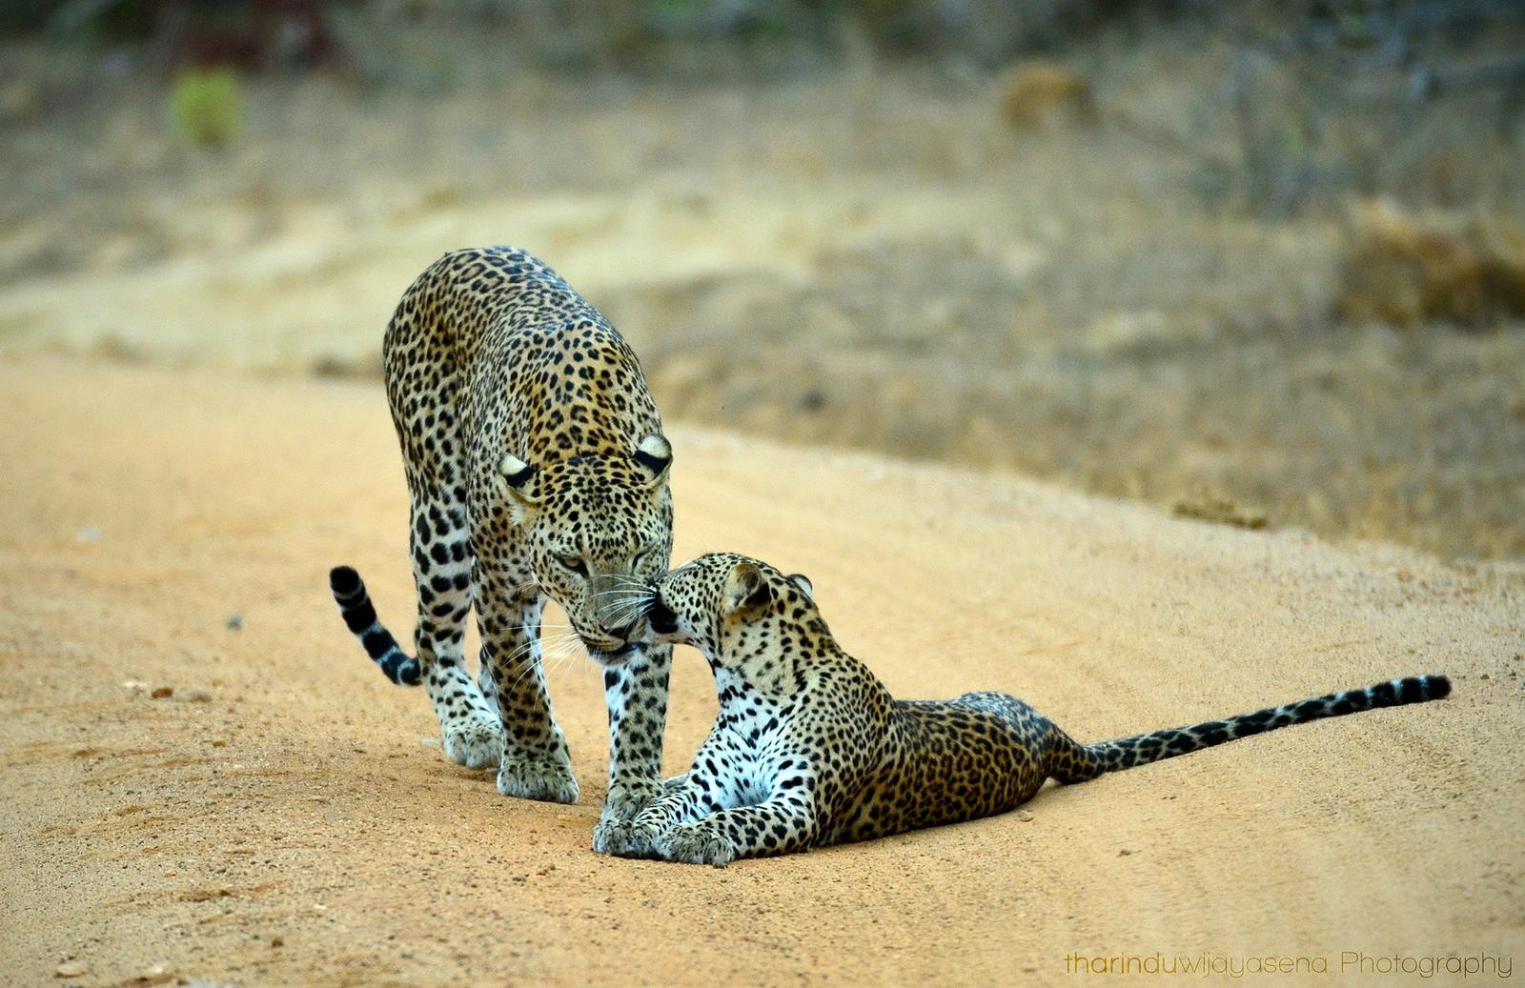
1

Sri Lanka
05 Nights& 06 Days

Sri Lanka is an Island blessed with beautiful beaches and perfect weather all year round if you’re the kind of person who likes to sit back and soak up the sun and enjoy some fresh seafood. Or maybe you’re more of an explorer who wants to know more about the beautiful aqua-marine creatures and plant life that inhabit the waters of the island. Whatever your preference maybe, we can find something that’s perfect for you. You can now choose from three breathtaking locations and immerse yourself in the absolute tranquil beauty that Sri Lanka has to offer.

Do you know Sri Lanka ranked as No1 Destination in the world to visit?
http://www.lonelyplanet.com/themes/best-in-travel/top-10-countries

Detail Itinerary

Day 01 – Airport/ Kandy Approx 3hr

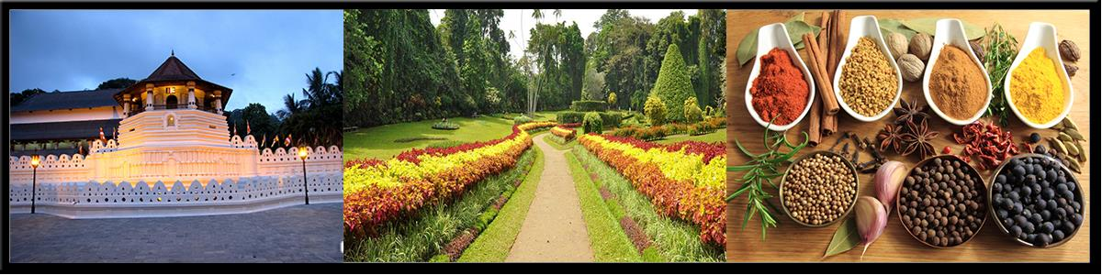
The ancient city of Kandy, located in Sri Lanka’s centre, is known to be the country’s cultural capital and an example of Sri Lanka’s rich cultural heritage. This beautiful city in the hills is ideal for relaxing and reflecting. The City is home to the tooth relic of the Lord Buddha and it is housed in the famous ‘DaladaMaligawa’ or ‘Temple of the Tooth’, which attracts thousands to the city every year including devotees as well as visitors who come to marvel at the beautiful architecture of the temple. Kandy is also home to many other old temples and other landmarks, including the amazing Peradeniya Botanical Gardens.
Day 01– Kandy
•
•
•
•
•
Arrival and assistant at the airport proceed to Kandy
En route visit Pinnawala elephant orphanage
Check-in at the hotel
Evening witness the cultural show Overnight stay at the hotel



Day 02 – Kandy / Nuwara Eliya City (Little England) Approx 03hrs

NuwaraEliya, known as the garden city of Asia for its hills, valleys and waterfalls, is 6,182 feet above sea level and is situated at the foot of Mount Pidurutalagala, Sri Lanka's highest peak. NuwaraEliya was discovered in 1819 by Sir Samuel Baker, the famous explore who discovered the source of the Nile. Thereafter, an English village was established, the remains of which can still be seen. The colonial government habitually moved to NuwaraEliya for 3 months of the year: March, April and May, when Colombo was warm and humid. Since then, thousands of domestic and foreign tourists sojourn in NuwaraEliya, to relish the salubrious climate, play golf, enjoy the park, admire the high grown tea plantations, visit the Hakgala gardens grown tea plantations, visit the Hakgala gardens and travel to Worlds End at Horton Plains, where there is a sudden drop in the terrain of several thousand feet.
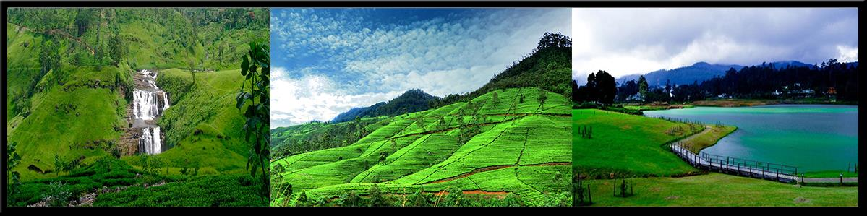
Day 02– NuwaraEliya
•
•
After breakfast at the hotel, Proceed to Nuwaraeliya known as Little England
En route proceed on Kandy city tour, Hanuman temple, Ramboda waterfall and tea
plantations and ramboda water fall
•
•
•
Visit beautiful waterfalls in Hill country
Check in to the hotel & relax
Overnight Stay at the hotel



Day 03 & 04 – Nuwara Eliya/ Bentota& Galle (Beach Location) Approx 04hrs

Bentota and its breathtaking sandy beach pretty much transforms your dreams and visions of a tropical paradise into an everyday reality. Located close to the Southern tip of the Island of Sri Lanka and only about 200 km from the Equator, this secluded crescent shaped beach is the perfect place to sit back, relax and forget about all the hustle and bustle of your other life that’s a million miles away. This small sandy tropical beach boasts some of Sri Lanka’s best and most stunning sunsets and sunrises.
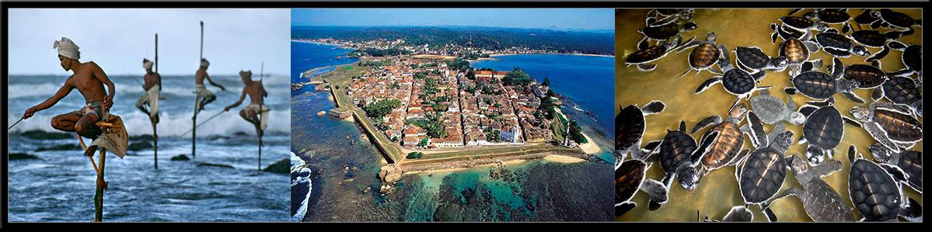
Day 03– Bentota (Beach Area)
•
•
•
After Breakfast at the hotel, proceed to Bentota
Check-in at the hotel
Overnight stay at the hotel
Day 04 - Bentota (Beach Area)
- After having breakfast at the hotel if interested proceed on Madu river boat ride and Kosgoda turtle farm and Galle city tour
- If interested water sports could be arranged at an additional cost
- Overnight stay at the hotel



Day 05 – Bentota / Colombo City (Capital of Sri Lanka) Approx 02hrs

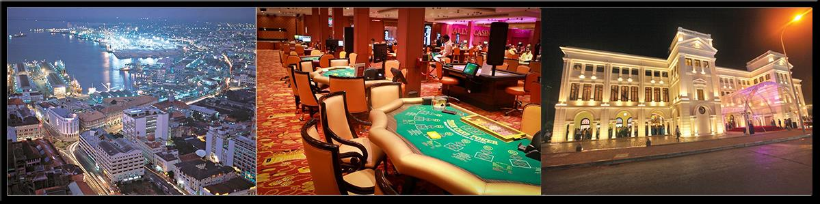
Colombo, the capital of Sri Lanka, brings together the old and the new. Colonial ruins and buildings contrast with high - rise hotels and commercial banks. Almost everyone who visits Sri Lanka spends time in this busy city. Colombo, an eighth century port, houses administrative, financial and other offices of relevance to the traveler. A part of other offices of relevance to the traveler.A part of finest structures of its colonial heritage. The city has developed, through several phases, into a modern city. The populace of Colombo is representative of Sri Lanka's ethnic and religious mixture.
Day 05– Colombo
•
•
•
•
After Breakfast at the hotel, proceed to Colombo
Check in to the hotel & relax at the hotel
Later proceed to Colombo on Colombo city tour
Overnight stay at the hotel



Day 06 – Departure
Day 06– Departure
•
•
After Breakfast at the hotel, proceed to Katunayaka International Airport for Departure
Good bye from Paradise Sri Lanka




Accommodation Plan – 3*
Days | Location | Hotel Name | Star Category | Room Category | Meal Plan
Day 1 | Kandy | Royal Kandyan | 3 Star | Deluxe | Half Board
Day 2 | Nuwara Eliya | Hotel Ashford | 3 Star | Deluxe | Half Board
Day 3 | Bentota | Earl’s Reef | 3 Star | Deluxe | Half Board
Day 4 | Bentota | Earl’s Reef | 3 Star | Deluxe | Half Board
Day 5 | Colombo | Ocean Edge | 3 Star | Deluxe | Half Board
Day 6 | Departure

Accommodation Plan – 4*
Days | Location | Hotel Name | Star Category | Room Category | Meal Plan
Day 1 | Kandy | Grand Kandyan | 4 Star | Deluxe | Half Board
Day 2 | Nuwara Eliya | Araliya Red | 4 Star | Deluxe | Half Board
Day 3 | Bentota | The Palms | 4 Star | Deluxe | Half Board
Day 4 | Bentota | The Palms | 4 Star | Deluxe | Half Board
Day 5 | Colombo | GranBell | 4 Star | Standard Sea view | Half Board
Day 6 | Departure

Accommodation Plan – 5*
Days | Location | Hotel Name | Star Category | Room Category | Meal Plan
Day 1 | Kandy | Golden Crown | 5 Star | Deluxe | Half Board
Day 2 | Nuwara Eliya | Araliya Green City | 5 Star | Deluxe | Half Board
Day 3 | Bentota | Cinnamon Bey | 5 Star | Deluxe | Half Board
Day 4 | Bentota | Cinnamon Bey | 5 Star | Deluxe | Half Board
Day 5 | Colombo | Cinnamon Grand | 5 Star | Premier Room | Half Board
Day 6 | Departure

Inclusions (Above Price Includes)

- Airport pick up and drop off
- Assistance at the airport
- Accommodation on half board basis on mention hotels below
- Private luxury car (air-conditioned)
- Private English Speaking chauffeur guide for the entire journey
- Kandy city tour
- Galle city tour
- Colombo city tour
- Nuwara Eliya city tour
- Ceylon Gem Factory visit
- Ceylon Batik clothing factory visit
- Sri Lanka Handicraft factory visit
- All government taxes
- Fuel & local insurance for the vehicle

Exclusions (Above Price Excludes)

- Air-tickets NOT included
- Sightseeing entrance charges (Unless Specified)
- Meals not mentioned in the itinerary
- Camera & video permits
- Guide/Driver tips
- Personal expenses
- Late check outs & early check in charges

Flights:

- Not Active on this tour

Additional Information:

- This is only quote and no reservations have been made as yet. All hotels are subjected to availability.


Cancelation Policy
- In case of cancelation, the following cancelation charges will be applicable
- Less than 30 Days 50% of the Total Invoice
- Less than 25 Days 100% of the Total Invoice
- No Show & Early Check - 100% of the Total Invoice

Activity List and Entrance Cost

NOTE: The entrance costs of the above activities are not included in package cost

Sightseeing entrance charges | Rates (In USD)
Turtle Hatchery | $ 4 Per Person
Boat Ride (Madu Ganga) | $ 15 Per Person
Whale watching | $ 50 Per Person
Pinnawala elephant orphange | $ 18 per person
Temple of tooth relic kandy | $ 10 per person
Hakgala botanical garden | $ 13 per person
Peradeniya botanical garden | $ 13 per person
Water sport one round jet ski, one round banana boat, one round tube boat | $ 25 Per Person

End of Package

